Stock Maintenance System

Use case :

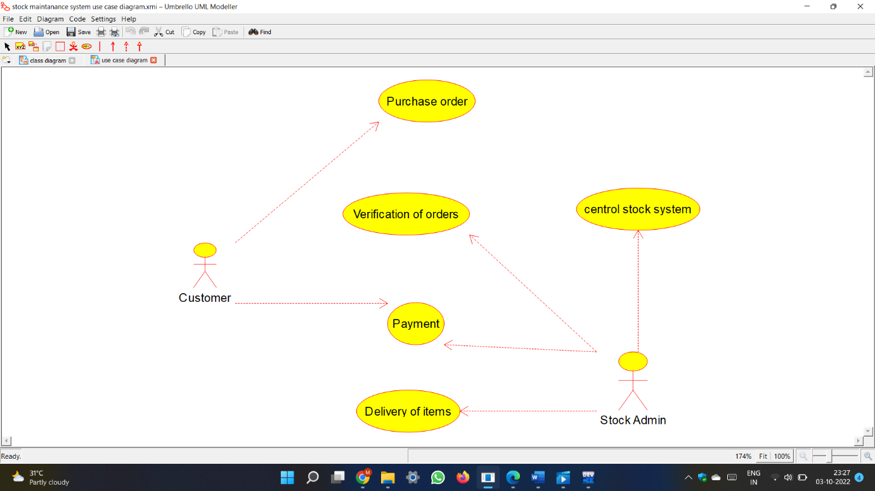

Class diagram :

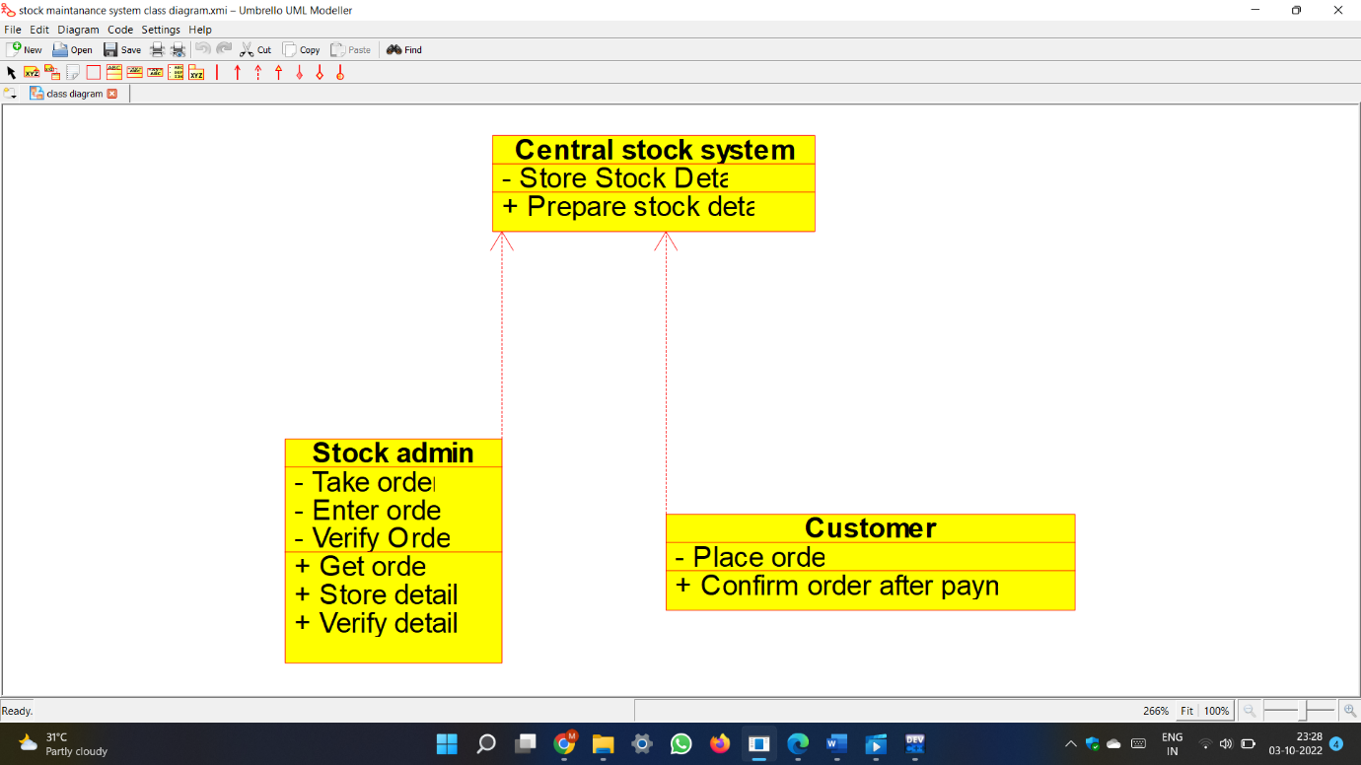

Code :

#ifndef STOCK_ADMIN_H

#define STOCK_ADMIN_H

#include <string>

/**

* class Stock_admin

*

*/

class Stock_admin

{

public:

// Constructors/Destructors

//

/**

* Empty Constructor

*/

Stock_admin ();

/**

* Empty Destructor

*/

virtual ~Stock_admin ();

// Static Public attributes

//

// Public attributes

//

// Public attribute accessor methods

//

// Public attribute accessor methods

//

/**

*/

void Get_order ()

{

}

/**

*/

void Store_details ()

{

}

/**

*/

void Verify_details ()

{

}

protected:

// Static Protected attributes

//

// Protected attributes

//

public:

// Protected attribute accessor methods

//

protected:

public:

// Protected attribute accessor methods

//

protected:

private:

// Static Private attributes

//

// Private attributes

//

void Take_order;

void Enter_order;

void Verify_Order_;

public:

// Private attribute accessor methods

//

private:

public:

// Private attribute accessor methods

//

/**

* Set the value of Take_order

* @param new_var the new value of Take_order

*/

void setTake_order (void new_var) {

Take_order = new_var;

}

/**

* Get the value of Take_order

* @return the value of Take_order

*/

void getTake_order () {

return Take_order;

}

/**

* Set the value of Enter_order

* @param new_var the new value of Enter_order

*/

void setEnter_order (void new_var) {

Enter_order = new_var;

}

/**

* Get the value of Enter_order

* @return the value of Enter_order

*/

void getEnter_order () {

return Enter_order;

}

/**

* Set the value of Verify_Order_

* @param new_var the new value of Verify_Order_

*/

void setVerify_Order_ (void new_var) {

Verify_Order_ = new_var;

}

/**

* Get the value of Verify_Order_

* @return the value of Verify_Order_

*/

void getVerify_Order_ () {

return Verify_Order_;

}

private:

void initAttributes () ;

};

#endif // STOCK_ADMIN_H

#ifndef CUSTOMER_H

#define CUSTOMER_H

#include <string>

/**

* class Customer

*

*/

class Customer

{

public:

// Constructors/Destructors

//

/**

* Empty Constructor

*/

Customer ();

/**

* Empty Destructor

*/

virtual ~Customer ();

// Static Public attributes

//

// Public attributes

//

// Public attribute accessor methods

//

// Public attribute accessor methods

//

/**

*/

void Confirm_order_after_payment ()

{

}

protected:

// Static Protected attributes

//

// Protected attributes

//

public:

// Protected attribute accessor methods

//

protected:

public:

// Protected attribute accessor methods

//

protected:

private:

// Static Private attributes

//

// Private attributes

//

void Place_order;

public:

// Private attribute accessor methods

//

private:

public:

// Private attribute accessor methods

//

/**

* Set the value of Place_order

* @param new_var the new value of Place_order

*/

void setPlace_order (void new_var) {

Place_order = new_var;

}

/**

* Get the value of Place_order

* @return the value of Place_order

*/

void getPlace_order () {

return Place_order;

}

private:

void initAttributes () ;

};

#endif // CUSTOMER_H

#ifndef CENTRAL_STOCK_SYSTEM_H

#define CENTRAL_STOCK_SYSTEM_H

#include <string>

/**

* class Central_stock_system

*

*/

class Central_stock_system

{

public:

// Constructors/Destructors

//

/**

* Empty Constructor

*/

Central_stock_system ();

/**

* Empty Destructor

*/

virtual ~Central_stock_system ();

// Static Public attributes

//

// Public attributes

//

// Public attribute accessor methods

//

// Public attribute accessor methods

//

/**

*/

void Prepare_stock_details ()

{

}

protected:

// Static Protected attributes

//

// Protected attributes

//

public:

// Protected attribute accessor methods

//

protected:

public:

// Protected attribute accessor methods

//

protected:

private:

// Static Private attributes

//

// Private attributes

//

void Store_Stock_Details;

public:

// Private attribute accessor methods

//

private:

public:

// Private attribute accessor methods

//

/**

* Set the value of Store_Stock_Details

* @param new_var the new value of Store_Stock_Details

*/

void setStore_Stock_Details (void new_var) {

Store_Stock_Details = new_var;

}

/**

* Get the value of Store_Stock_Details

* @return the value of Store_Stock_Details

*/

void getStore_Stock_Details () {

return Store_Stock_Details;

}

private:

void initAttributes () ;

};

#endif // CENTRAL_STOCK_SYSTEM_H

Activity diagram :

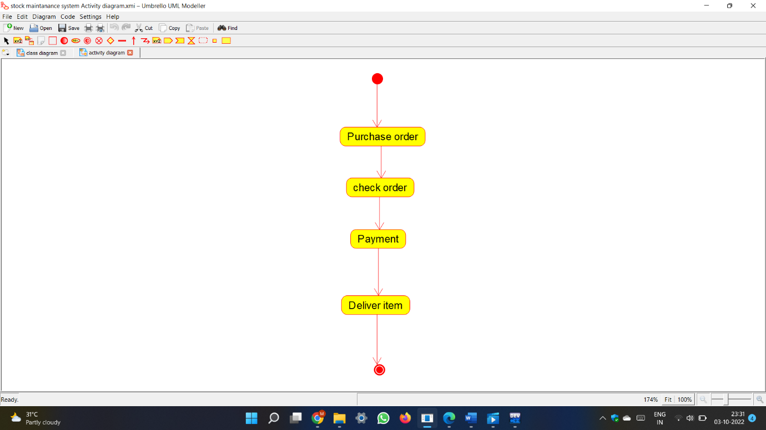

Component diagram :

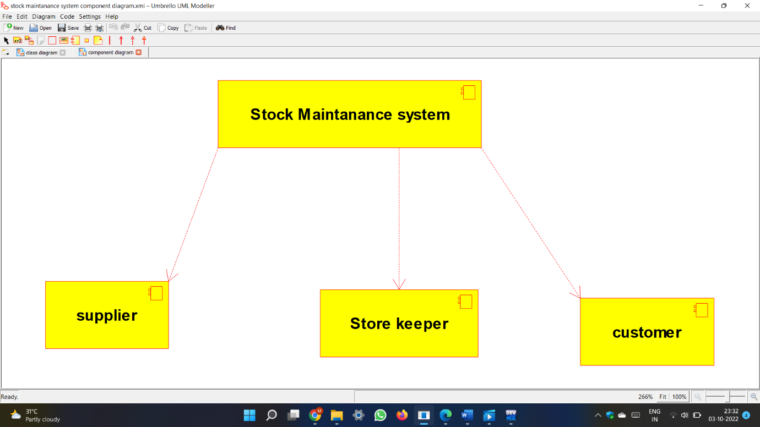

Deployment Diagram :

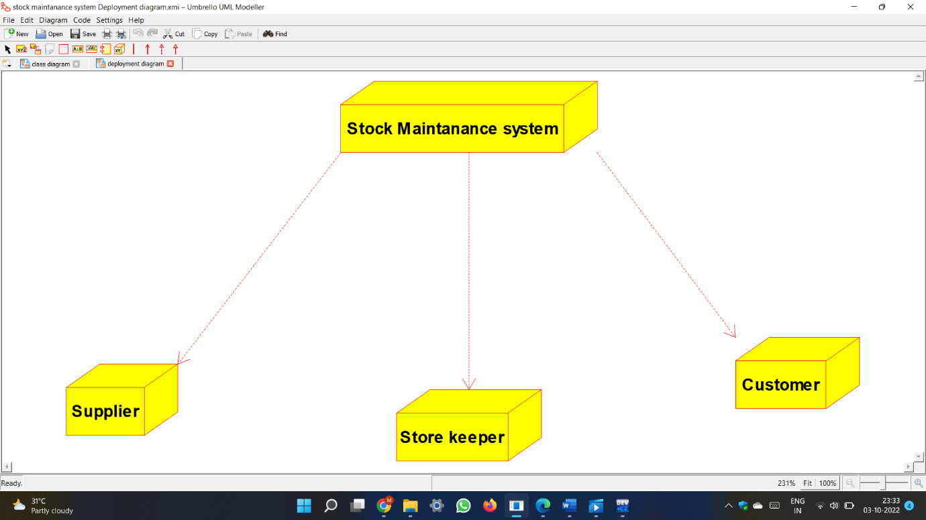

Sequence diagrams :

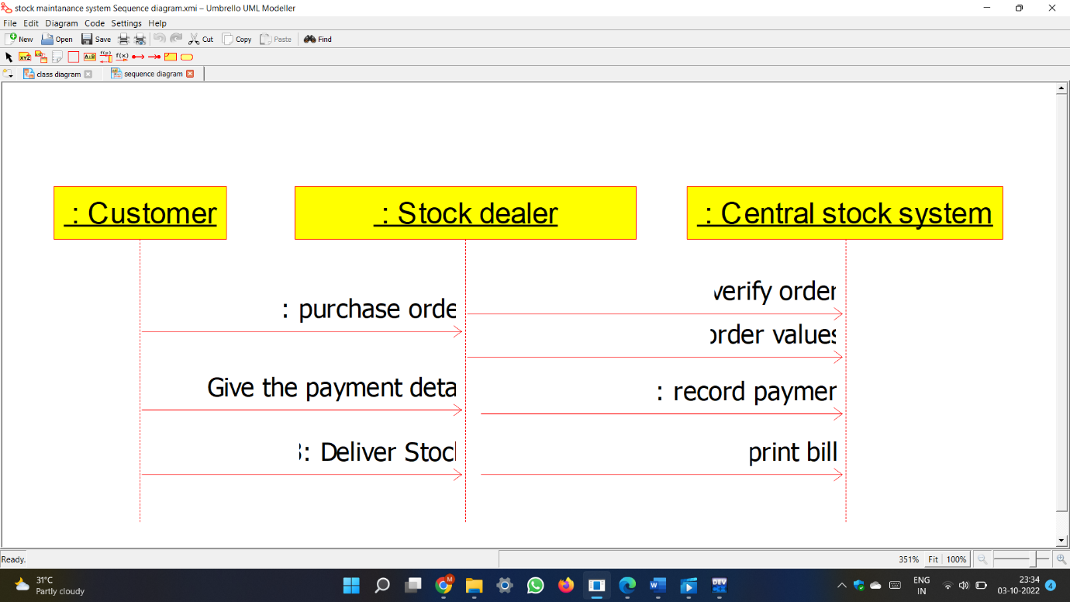

State chart diagram :

